Data procedures:

1. Data was collected and given by UpGrad (E-learning platform) while undertaking module 7 of ‘Business Analytics’ course.
2. Received on 27th Aug,2020
3. Spreadsheet name ‘Module 7.2 Address.xlsx’.

Cleaning:

1. Added new column “pincodeCheck” to ensure pin codes are of 6 digits only.
2. Found 7 invalid values in the column “Pincode”

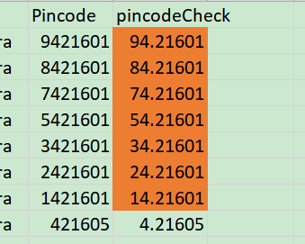

1. Since, Mumbai pin code starts with ‘4’, we get the last 6 digits of the pin code by IF(LEN(E2)>6,RIGHT(E2,LEN(E2)-1),E2)

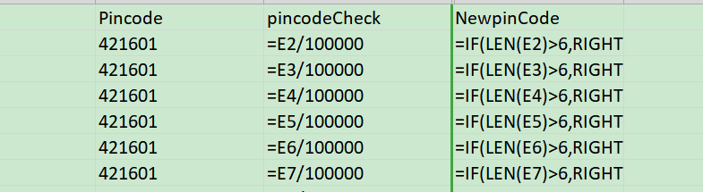

Calculations:

1. No of rows with Pincode = 421601 is 35.

By formula =COUNTIF(E1:E1124,421601)